**Name: Carlos Lopez Table: N/A Section:** **M6**

m

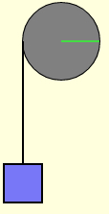**Discussion : Rotational Dynamics**

A block of mass 2*m* hangs from a string wrapped around a pulley of mass *m*. The pulley is a uniform solid disk of radius *R* rotating without friction about the center, so



2m

The system is released from rest. First, we’ll apply energy ideas.

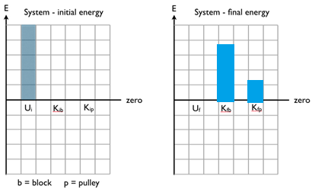**Approach 1:** define the system as the Earth, the block, the pulley, and the string.

The energy bar graphs are shown for the initial situation. Sketch the energy bar graphs for the final situation, after the system has been released from rest and the block has dropped through a height *h*, where the final potential energy is zero.

**Hint**: Write out the five-term energy equation for the system.

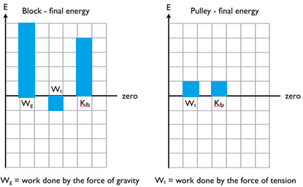

**Approach 2:** Now, we’ll look at two separate pieces of the system, just the block by itself and just the pulley by itself. Again, sketch energy bar graphs for these two objects after the system has been released from rest and the block has dropped through a height *h*. Note that the initial energy bars would all be zero.

Based on the bar graphs, if the force of gravity acting on the block is 2*mg*, how large is the force of tension, in terms of *mg*?

**.2mg**

Check your work by comparing to the bar graphs shown in this simulation:

m

http://physics.bu.edu/~duffy/HTML5/block_and_pulley_energy.html

Make sure to scroll down to read the text below the simulation.

2m

Now, we’ll apply forces and torques to this same situation, where the block has a mass 2*m* and the pulley has a mass *m*.

**The block:** Sketch a free-body diagram of the block, as it is accelerating down. Apply Newton’s second law to get an equation relating the block’s acceleration to the forces acting on the block.

**The pulley:** Sketch a free-body diagram of the pulley, as it is accelerating counter-clockwise. Apply Newton’s second law for rotation, and simplify it, to get an equation relating the block’s acceleration to the forces acting on the pulley.



**Combine the equations:** Combine the equations to find (i) the acceleration in terms of *g*, and (ii) the force of tension in terms of *mg*.

Consider the following variation.

In the limit that the pulley mass is much larger than the block …

The tension in the string would ***approach*** the block’s Force of gravity (2mg in this case)

And, the energy bar graphs would ***approach***… (fill them in below)

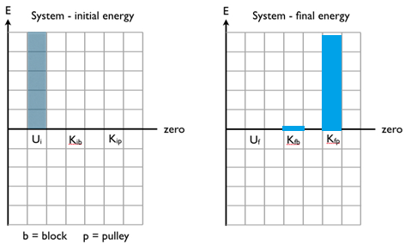**Approach 1:** define the system as the Earth, the block, the pulley, and the string.

The energy bar graphs are shown for the initial situation. Sketch the energy bar graphs for the final situation, after the system has been released from rest and the block has dropped through a height *h*, where the final potential energy is zero.

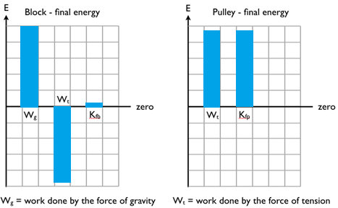

**Approach 2:** Now, we’ll look at two separate pieces of the system, just the block by itself and just the pulley by itself. Again, sketch energy bar graphs for these two objects after the system has been released from rest and the block has dropped through a height *h*. Note that the initial energy bars would all be zero.